BrightLearn
AI & Data Skills
UNION & UNION ALL Exercise — Query Results
Platform: Databricks SQL
Student: siyakha Ntuli

Q1. Combine account holders from both branches into one unique list.


Q2. Build a unique product catalogue from both product lists.
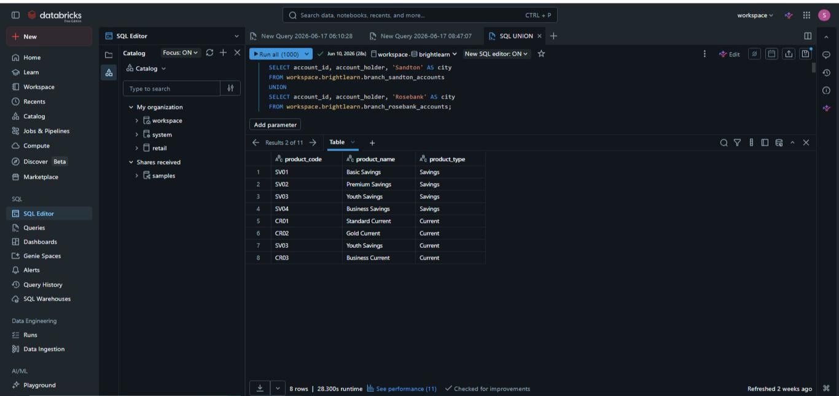

Q3. Unique list of all staff from Retail Banking and Corporate Banking.
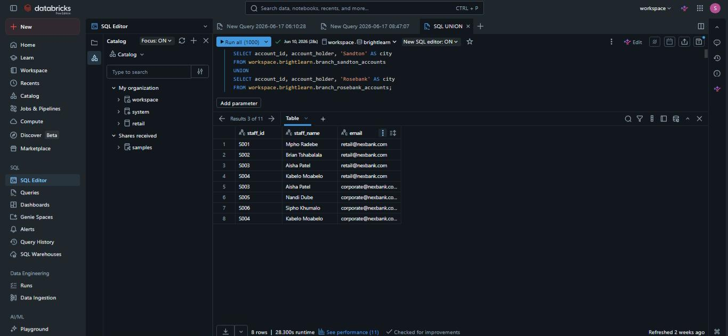

Q4. Unique list of all cities where NexBank serves customers.


Q5. Unique list of every customer targeted by either campaign.


Q6. Complete log of ALL ATM transactions including duplicates.
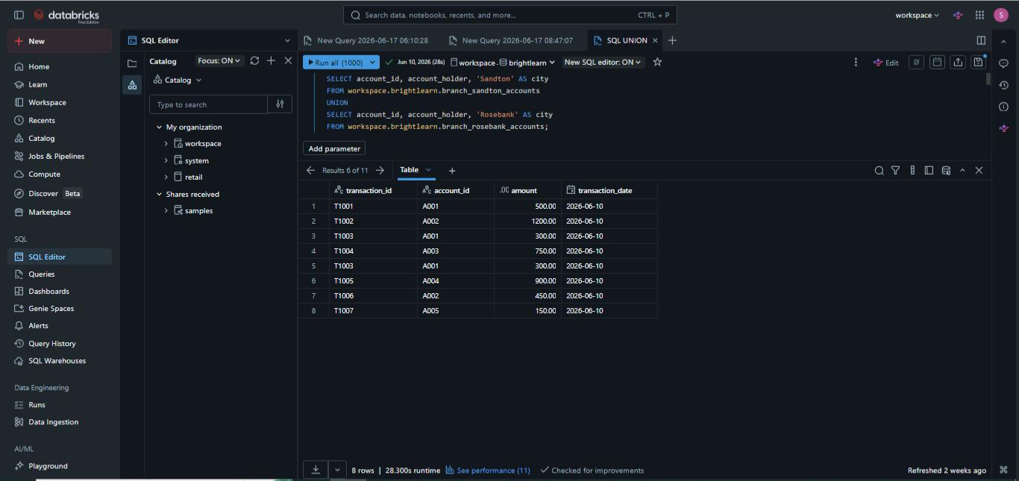

Q7. Full list of all loan applications from both regions including duplicates.
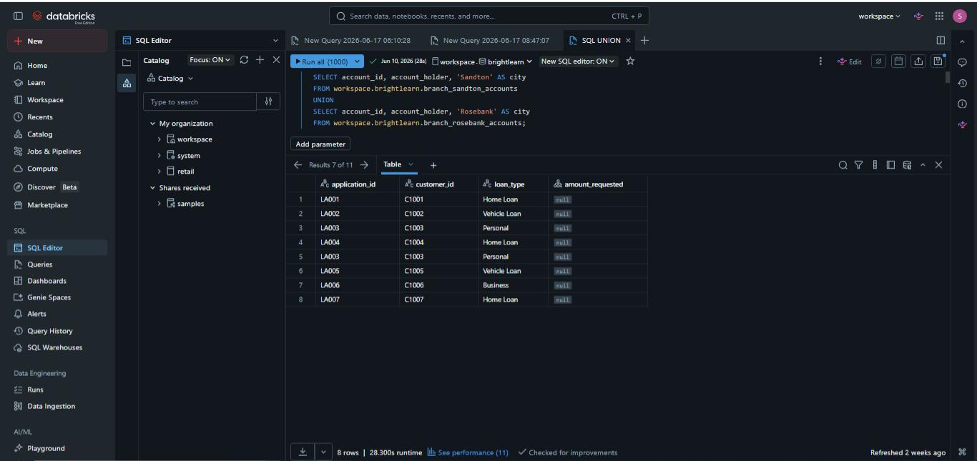

Q8. Full record of every complaint from email and app.
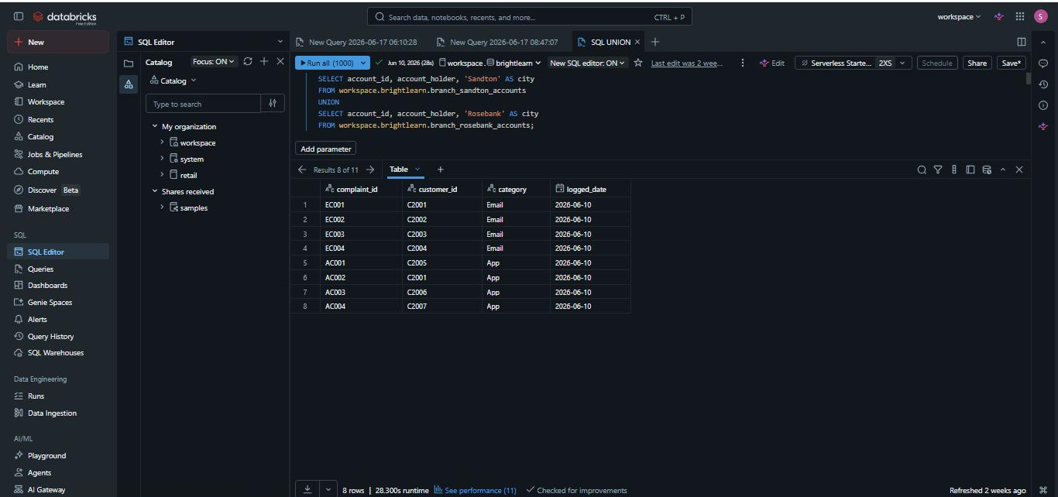

Q9. All payment records from April and May combined.
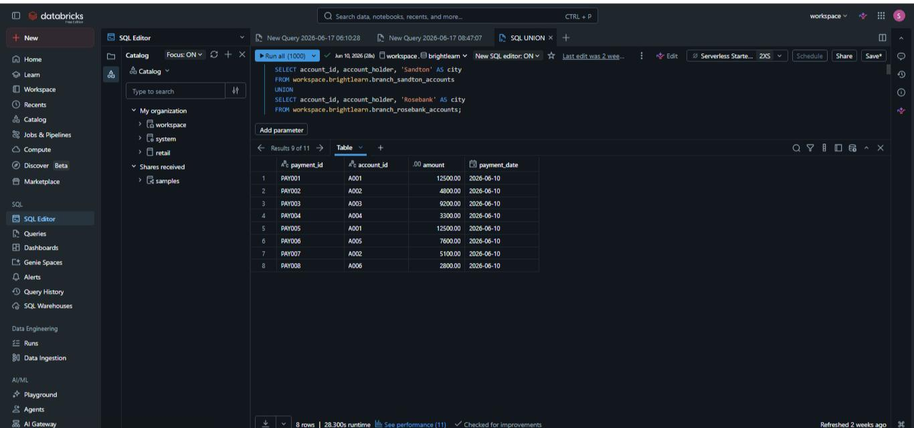

Q10. Combine all debit and credit entries into one general ledger.
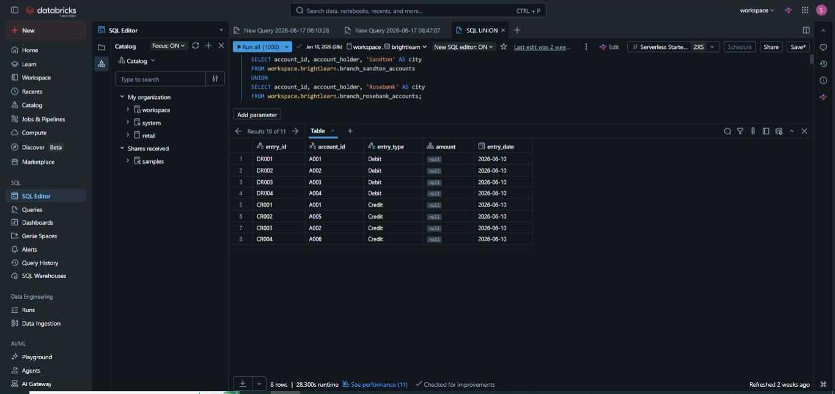

BONUS 1. A fraud analyst wants a unique list of customers from January or February high-risk watch lists. Should they use UNION or UNION ALL? Explain why.
Use UNION. The analyst wants a unique list of customers, anyone who appears on both the January and February watch lists should still only show up once. UNION’s automatic deduplication is exactly what’s needed here; UNION ALL would let flagged customers appear twice, inflating the list.

BONUS 2. The auditing team wants to count every individual transaction in Q1, even if recorded in two systems on the same day. Should they use UNION or UNION ALL? Explain why.
Use UNION ALL. The team is counting every individual transaction, including ones recorded twice due to system overlap. If they used UNION, the deduplication would silently drop one of the two duplicate records, undercounting the true transaction volume. For row-count-sensitive tasks like reconciliation or auditing, UNION ALL is almost always correct.

BONUS 3. A developer writes: SELECT account_id, account_holder FROM branch_sandton_accounts UNION SELECT account_id, account_holder, city FROM branch_rosebank_accounts. The query fails. What is wrong and how would you fix it?
The query fails because the two SELECT ’tatements don’t return the same number of columns, the first selects 2 columns (account_id, account_holder), the second selects 3 (account_id, account_holder, city). This breaks Rule #1: both sides of a UNION must have matching column counts.

